2016Jul4 Trading

Wednesday, July 06, 2016

Got back from Amoy yesterday.

Today , first minute is down, first 5 is up, first 10 is down.

After a monstrous rise on Monday, market is very weak today. Looks like market is in consolidation mode. This level is quite crucial in determining whether it will break up 3000 or not.

Jun24 was the day of the Brexit vote. Market initially went up on expectation of the Bremain. Then as odds worsened, market quickly plunged. The next Monday China significantly outperformed world. On Tuesday and Wednesday, markets massively rose in the afternoon.

Observations:

HSCEI is much more affected by the other markets. A share outperformed H share massively recently. On jun27, china's relief rally was earlier and stronger than all other markets; H shares had a relief during the session but Europe dragged it down. Tues-Wed was massive. I was short on Tuesday from the AM ( this was very stupid in hindsight), and I covered the position on Thursday. Monday A shares massively rallied again, both H and A reached a fresh high.

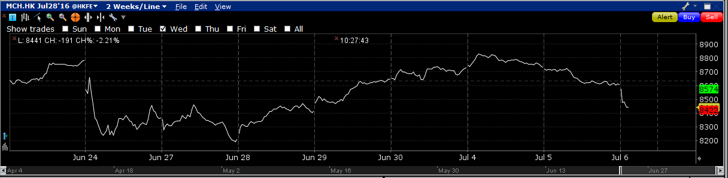

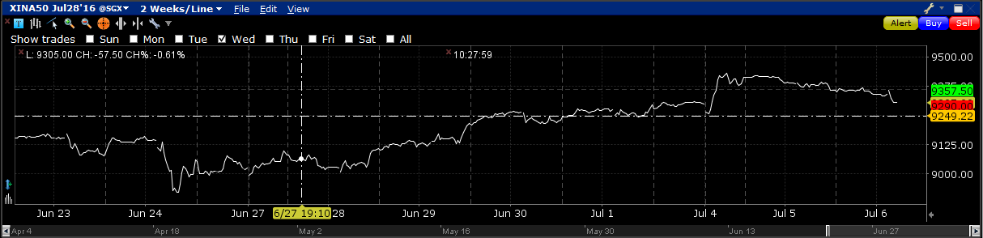

Afternoon performance is much stronger than expected.

It is quite rare to break CloseY in the pm (only 23/117) broke.

|  |
| --- |
| pmMax > CloseY 0% 25% 50% 75% 100%  1: FALSE 94 0 94 13.01667 13.03333 13.84167 14.38333 15  2: TRUE 23 23 0 13.68333 14.45000 14.66667 15.00000 15 |
|  |
| Looking at the percentile of the pmmax, a position is entered near this level (at today's high).  Potential risk is that the low AM performance will drag down the PM.  The fact that PMmax could break above.  在9350左右横盘.  Trying to compute the first crossing time in R.   |  | | --- | |  | |

Thursday, July 07, 2016

I don't quite understand the market logic nowadays. Now it is 14:10 pm, market massively rallied. I am short because yesterday's closing percentile was at the highest. Yesterday for most of the day the index was trading below closeY, but towards the close it rallied to the closeY. For today, market massively rallied at 2pm. It could be a trap to get people buying. Today's apparently not the typical Thursday. PmFirst10 was bullish. People are looking forward to a strong Friday.

From looking at the market, the market doesn't want to go down at all. This might be the start of a bullish session -> even on Thursdays markets can display such remarkable strength.

Flipped to long, the reason being the market clearly doesn't want to go down.

The strength recently is incredible -> no short/buy dip now.

Today the trading strategy was correct in shorting with a negative amFirst10.

Friday:

Yesterday US job numbers came out and mildly beat expectations. This increases chance of rate hike and is a negative for the market. But the uncertainty surrounding Europe is keeping a Cautious Yellen in check. The price action lately shows that as soon as external risk events alleviate, markets can't wait to shoot up, which means that the underlying mood is bullish. On Jun15, China was rejected from MSCI, and market rallied for the whole day. On Jun24, when the Brexit result came out, China rebounded massively in the afternoon, whereas Nikkei lost more than 7% that day. The next Monday, China had an all day rally, seemingly aware of the rebound that would come.

Weekly review:

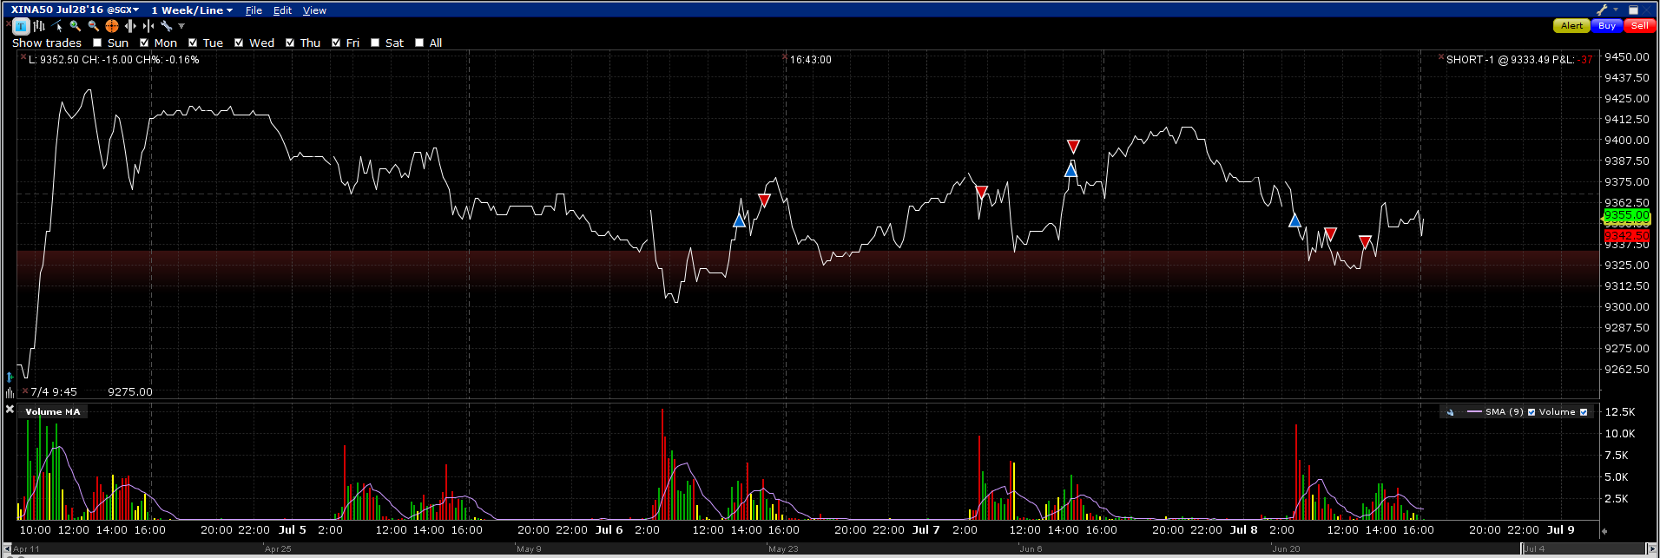

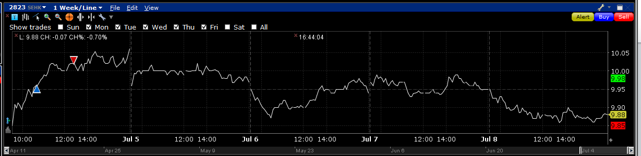

Trading this week did not generate any profits.

Monday: Opportunities were early in the AM. Traded with 2823. Sold the position in the PM because pmFirst10 was down, however, 2823 rallied into the close. j

Tuesday: Market started dropping at around 2:30. 市场转弱.

Wed: Market was weak in the AM with amMax<closeY. However market still managed to rally in the PM.

Thursday: Market was weak in the AM with amMax<CloseY. I was short in the AM. Markets rebounded in the PM. I had to cut this position.

Friday: Bought in the AM but AMfirst10 was negative. Sold this position at the AM close. Due to pmFirst10<0, put on a short position. Market slightly rebounded and retreated into the close.

Lessons:

Instead of trading like this, focusing on trading retPMCL would be much better. On Thursday there was a positive pmFirst10, this warranted extra attention. The position wasn't covered in time which resulted in sub-optimal performance.